AI-Powered Identity Verification and Fraud Detection for KYC Compliance

1. Introduction
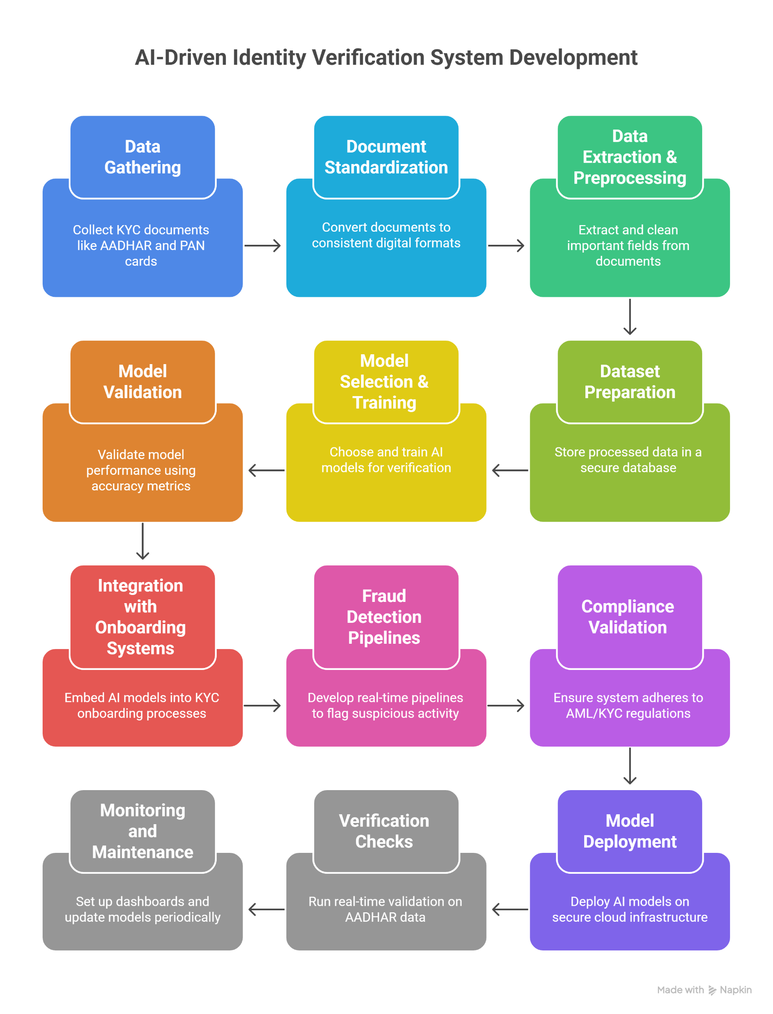

Modern KYC systems face increasing challenges due to the rise in identity fraud, forged documents, and synthetic identities. Traditional verification methods rely heavily on manual inspection, which is slow, inconsistent, and prone to human error. To overcome these challenges, the project integrates Artificial Intelligence—specifically Graph Neural Networks (GNNs), facial recognition, and document intelligence—to create a secure, scalable identity verification system.

Facial recognition helps verify whether the person submitting the document is the genuine owner by matching their live image with their AADHAR card photograph. Meanwhile, GNN-based fraud detection analyzes relationships, connections, and hidden patterns across datasets to detect coordinated fraud attempts, duplicate identities, and suspicious networks.
By combining these technologies, the system ensures faster onboarding, higher accuracy, and strong fraud prevention suitable for BFSI KYC/AML workflows.
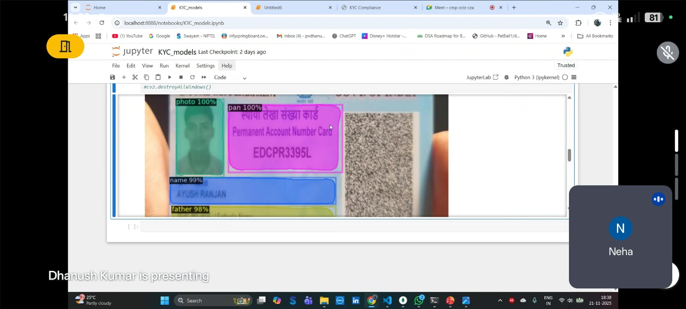

2. GNN (Graph Neural Network) Explanation for KYC Identity Verification –

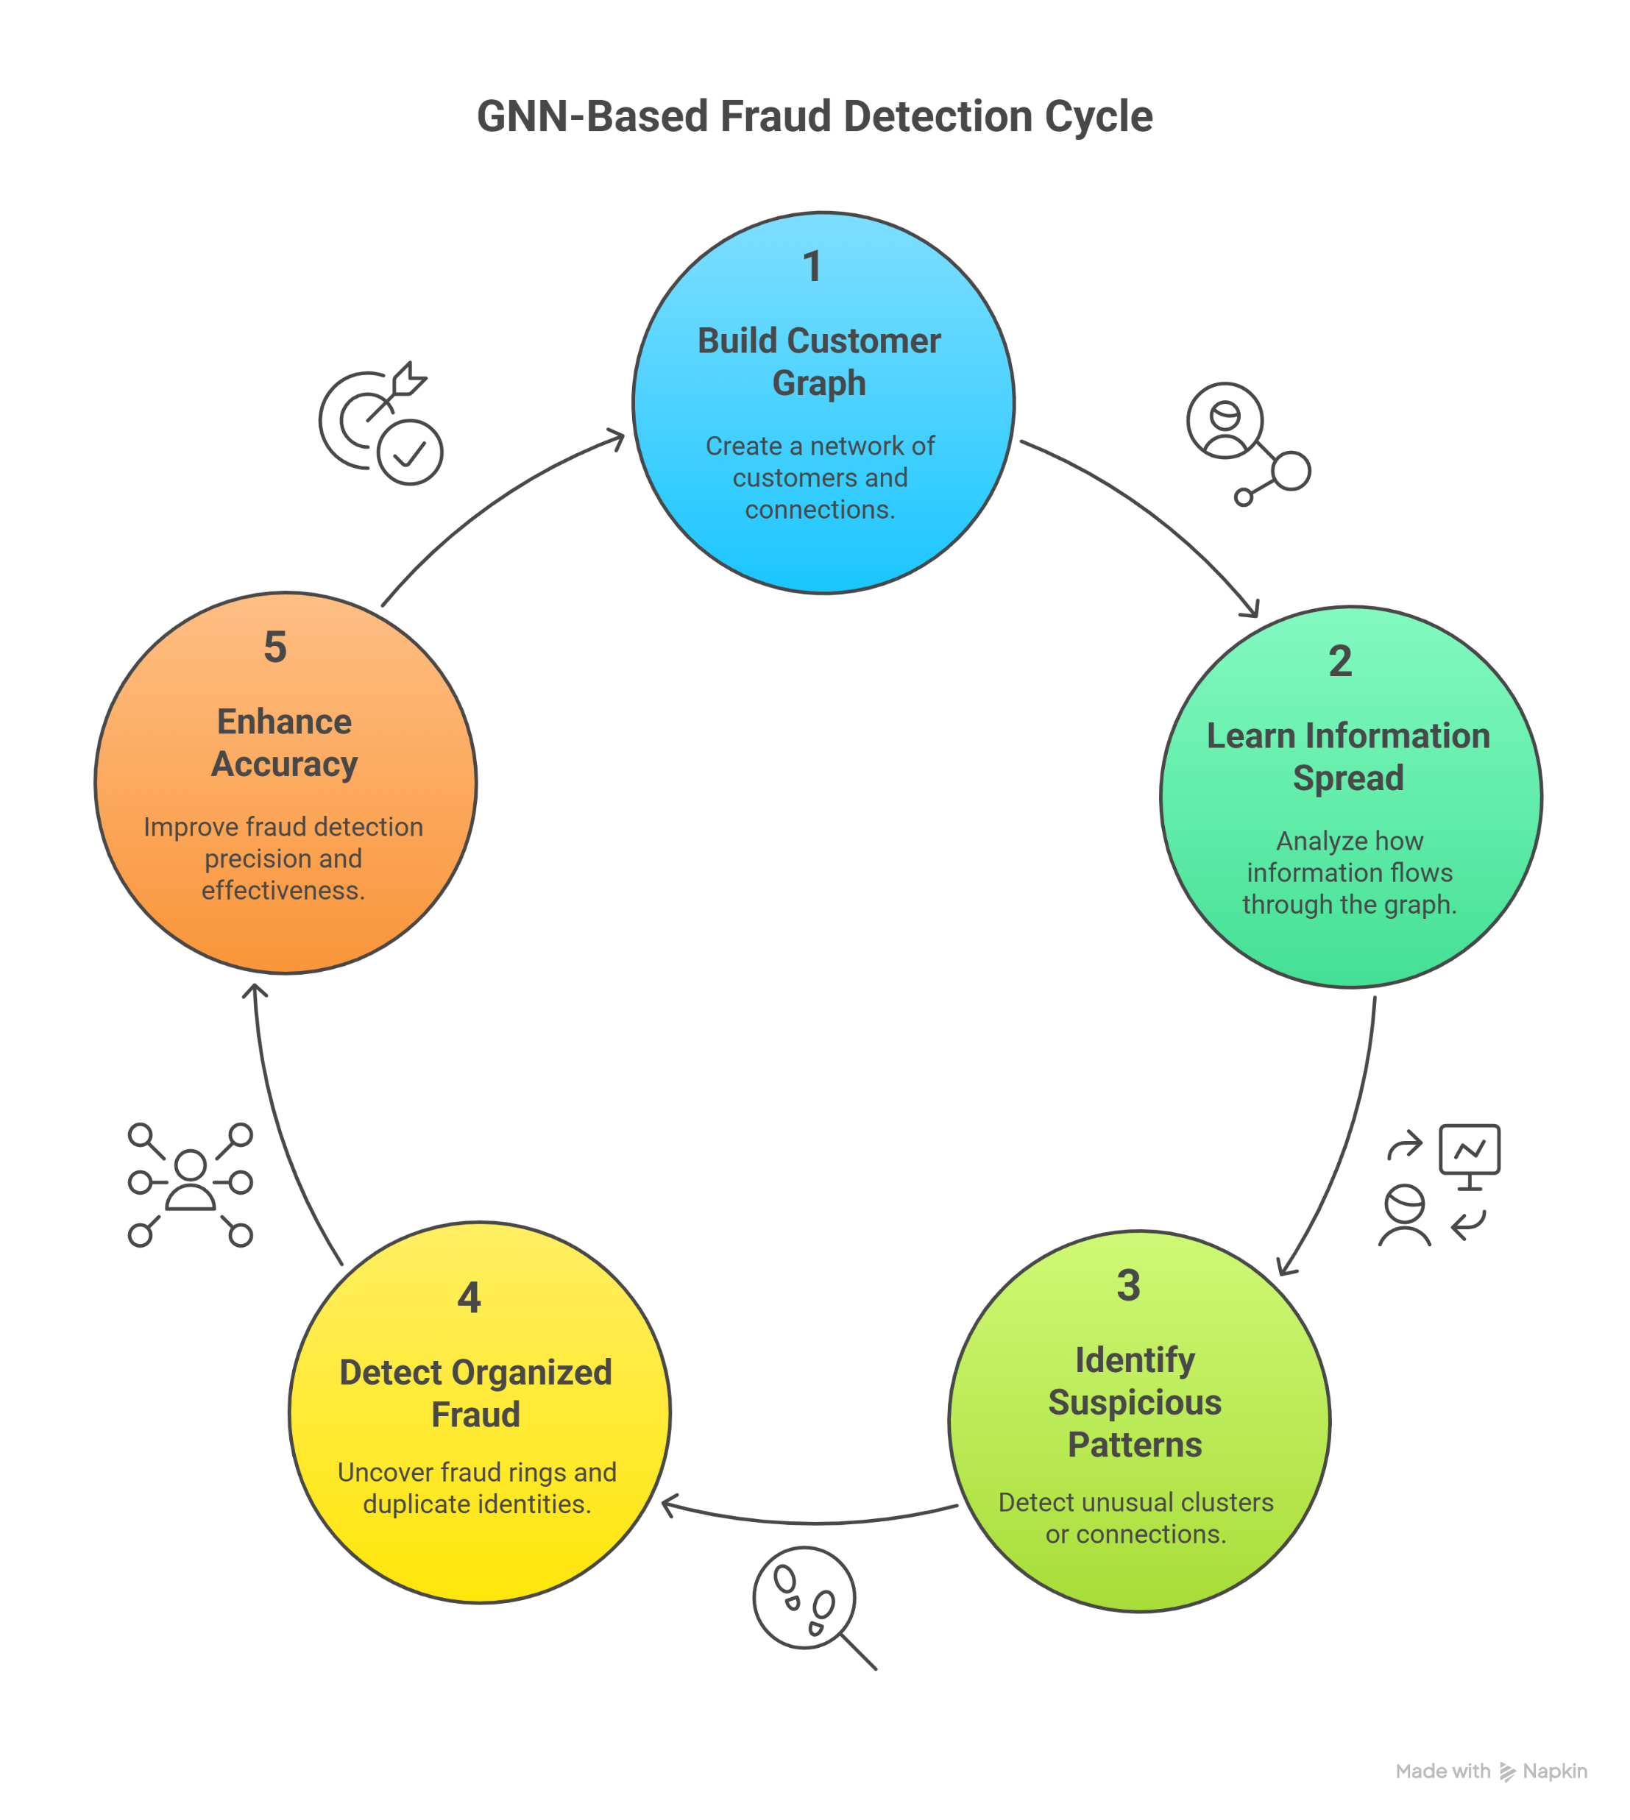

Graph Neural Networks (GNNs) play a critical role in detecting hidden fraud patterns in KYC data. Unlike traditional machine learning models, GNNs analyze relationships between people, addresses, phone numbers, devices, and documents.
In fraud detection, criminals often reuse the same phone number, device, or address across multiple fake accounts. GNN models identify these links by converting the data into a graph structure and learning fraud patterns from connections instead of individual values.
For example:
- One device used for multiple new accounts
- Same address used by different suspicious IDs
- Repeating behavioral patterns across accounts
This helps the system flag fraudulent clusters, detect identity theft, and prevent synthetic identity creation.

3. Objectives
- Automate identity verification
- Detect fraudulent addresses
- Ensure KYC/AML compliance
- Reduce manual workload
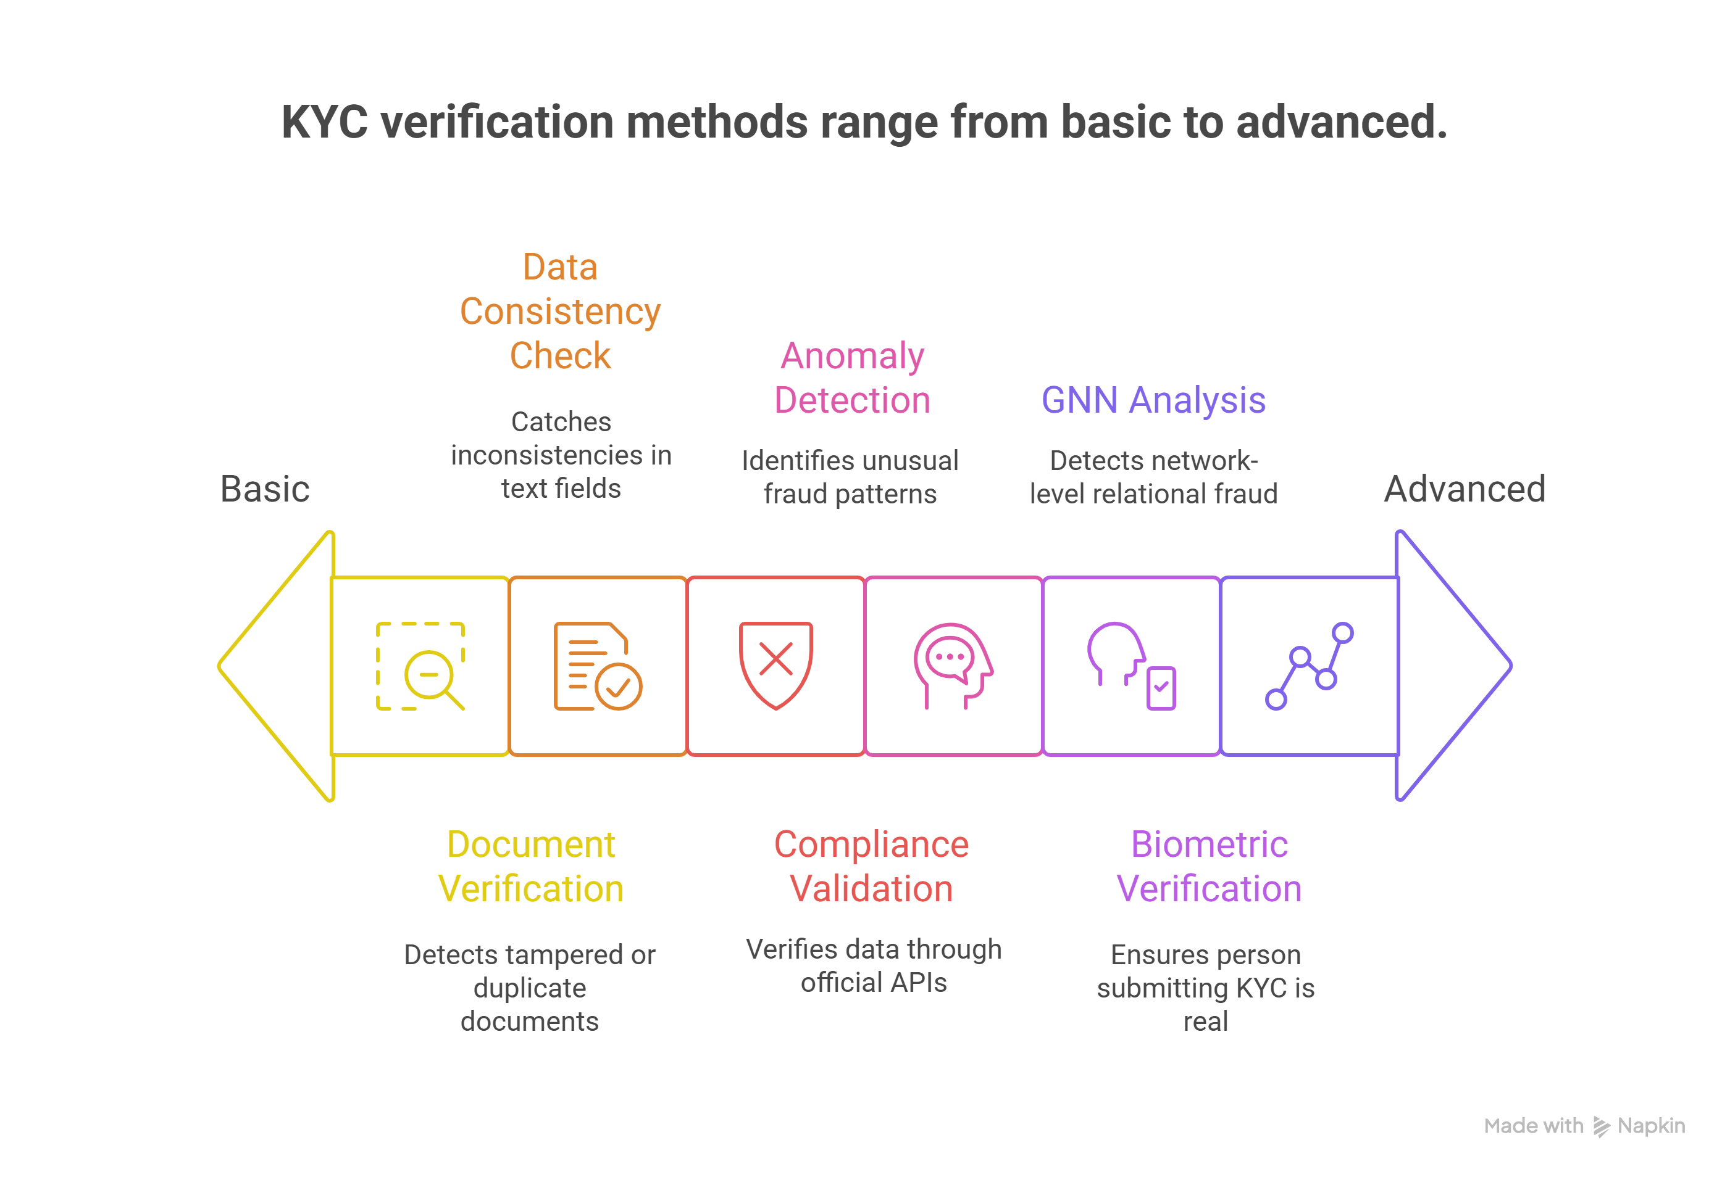

4. Scope of the Project
Scope includes data extraction, AI model development, compliance integration, and deployment.

The scope of this project extends beyond simple document verification. It includes AI-driven identity matching, address validation, fraud detection, and compliance automation. The system covers:
- Automated extraction of text and images from AADHAR and KYC documents
- Facial recognition for verifying the authenticity of the document holder
- GNN-based fraud detection for identifying duplicate accounts, impersonation, and suspicious networks
- Tamper detection on document images using computer vision
- Real-time decision-making workflows integrated within KYC/AML processes
- Secure storage, processing, and validation of sensitive identity information
This project focuses on creating a holistic AI-powered framework capable of meeting the security, accuracy, and scalability requirements of modern financial institutions.

